SELF PROFILE 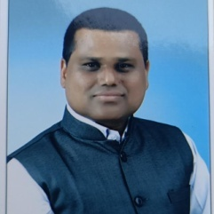

- Full Name: Dr. Dattatray Keraba Kamble
- Date of Birth: 01-06-1977
- Gender: Male
- Education Qualification: M.A.,B.Ed.,M.Phil.,Ph.D. (English)
- Date of Joining: 01-06-2007, at T.K.Kolekar Arts and Commerce College, Nesari , Tal: Gadhinglaj , Dist: Kolhapur
- Designation: Assistant Professor
- Teaching Experience: 14 years
- Residential Address: A/P: Karanjivane, Tal: Kagal, Dist: Kolhapur
Mob. No. : 7775934288
- Email Address: dattatrayk1977@gamil.com
- Participation Workshop: 17
- Paper Published: 13
- Participation and Paper Presentation: 24
- Resource Person: 6

