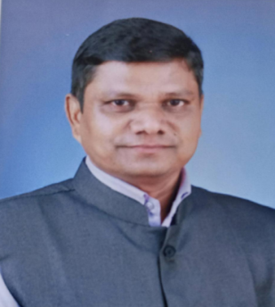
PERSONAL PROFILE
NAME : SASANE JAGADEESH KESHAVRAO
ACADEMIC QUALIFICATION : M.A. SET (SOCIOLOGY)
DESIGNATION WITH FACULTY: AAISIT. PROF. DEPARTMENT OF SOCIOLIGY
TEACHING EXPEERIENCE : 16 YEARS
Email: jsasane50@gmail.com
CONTRIBUTION TO CORPORATE LIFE:
- HEAD, UGC COMMITTEE (2014- 2021)
- HEAD ADMISSION COMMITTEE (2018-2021)
- HEAD, CULTUTAL COMMITTEE (TWO YEARS)
- MEMBER, CULTURALCOMMITTEE ( 3 YEARS)
- MEMBER/ WALL PAPER COMMITTEE
- MEMBER - MARATHI SAMAJSHASTRA PARISHAD,
MEMBER - SHIVAJI UNIVERSITY SAMAJSHASTRA PARISHAD KOLHAPUR,
MEMBER- INDIAN SOCIOLOGICAL SOCIETY, MEMBER-
- LIFE MEMBER FASTA
- WORKED AS A SUBJECT EXPERT (1 TIMES) LOCAL COLLEGE,PATANE FATA INTERVIEW
- PARTICIPATION IN UNIVERSITY ASSESSMENT WORK.
- ASSOCIATE EDITOR BOARD , SHODHYATRA KHAND 8 ISBN 978-81-925656-3-7

RESEARCH PAPERS : 19
INTERNATIONAL LEVEL PUBLICATIONS : 8
NATIONAL LEVEL PUBLICATIONS : 11

------------------------------------------------------------------------------------------------------------------------------------------------------------

