Personal Information 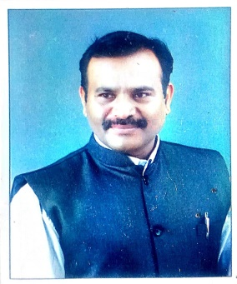

NAME :- DR. KOLASEKAR MANOHAR SUBRAV
ACADEMIC QUALIFICATION :- M.A, M.PHIL, PH.D
DESLGMATION WITH FACUITY :- HEAD, DEPT. OF HISTORY
TEACHING EXPEERIENCE :- UG. 24 YEARS
Email ID :- manoharkolasekar@gmail.com
Blogger ID :- https://shivpratapitihas.blogspot.com
Contribution To Corporate Life
Sr.No. | Name of the bodies | Designation | Year
1 | Department of history | Head | Since -1997…..
2 | N.S.S | Head (Co-ordinator) | 4 years
3 | Internal Educational Evaluation Exam Department | Head | 4 years
4 | Local management Committee | Member | 1997 To 2007
5 | Educational tour | Head | 2007-2016
6 | Time- table Committee | Head | 2006-2007
7 | Cultural activates | Head | 2006-2007
8 | Sports committee | Member | Since -2008……
9 | Proad & niranthan vibhag | Head | 2010 to 2012
10 | Balwadi shikshika coursa | Head | 2010 to 2012
11 | Naac committee, VI Criteria | Member | Since …2013
12 | Exam Dept., SUK | Membe | Since….2021
13 | Magazine Committee | Head | 2021 To….
14 | Subject expert In History | University level | Nine Time
15 | Staff secretary | Head | Since… 2007
16 | UGC Network Center | Head | 2011 to 2012
17 | Shivaji University History Association | Member | Life time
18 | Satara History Association | Member | Life time
19 | Maharashtra itihas prishad | Member | Life time
20 | Life member SUTA and MUST Teacher Association | Member | Life time
21 | Founder & Adviser for Shri Kaiamma Dudha Sanstha Lakurwadi | Member | Life time
22 | Sarvjanik vacnalay Nesari & Lakurwad | Member | Life time
23 | Blood Donation (4 Times)

Research activities.
Sr.No | Name of Degree | Title
1 | Ph.D | Social, political, education and cultural contribution of daily tarun bharat ( A.D 1919 to 1980)
2 | M.Phil | Bhai Dajiba Desai Life and Works
3 | Minor research Project | Maharashtra Karnataka Border Dispute and agro Tax Resistance Movement in Belgaum District

Research papers
49, Resarch Paper Presented and Participated In State , International and National
International level Paper publication :- 08
National level Paper publication :- 18
State level Paper Publication :- 10

