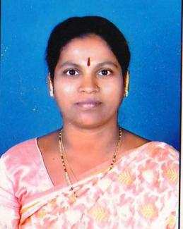
INDIVIDUAL PROFILE

- Full Name : Sou. Lokhande Sangita Kiran

- Date of Birth : 10,June,1973

- Caste : Hindu ,Mahar (SC)

- Gender : Female

- Education Qualification : M.A , B.Ed. , M.Phil,(History)

- Date of Joining : 28th Sept.1999 , T.K.Kolekar Arts & Commerce College,Nesari.

- Designation : Assistant Professor.

- Teaching Experience : 22 years

- Residential Address : “GURUMAULI NIWAS” Plot NO22,Sadguru
Colony,SunderNagar,Nesari,
Tal.Gadhinglaj, Dist.Kolhapur PIN.416504

- Email Address : sangitalokhande10@gmail.com

- Participation in Workshop : 36 Times.

- Paper Published : 5 Papers Published in Reputed Journals with ISSN Numbers.

- Participaton & Paper : 5 ,INTERNATIONAL,20, NATIONAL LEVEL SEMINAR AND
Presentation WORKSHOPS.
- Resource Person : 8 Times on Various Dias.

