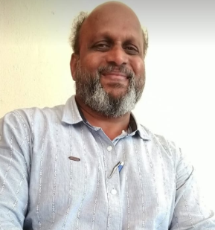
PERSONAL INFORMATION

NAME- Dr.Vijay Birappa Musai.
ACADEMIC QUALIFICATION- M.A., M.Phil., Ph.D. [M.S.–CIT]
DESIGNATION WITH FACULTY - Head, Dept.of Sociology.
TEACHING EXPEERENCE- 24 Years in U. G .Level.
E MAIL I D- vijaymusaisoci@gmail.com
CONTRIBUTION TO CORPORATE LIFE
- HEAD-Department of sociology
- CO-CO-ORDINATOR - IQAC for Accreditation and Reaccreditation (2nd Cycle)
- PROGRAM CO-COORDINATOR- Cultural Dept. for six years
- PROGRAM CO-COORDINATOR- Worked as U.G.C’s Human Right Educations foundation course
- MEMBER - L.M.C. Local management committee (From-since 1997to 2016)
- EXAM.DEPT,SUK- External Senior Supervisor of shivaji university Kolhapur for six session
- SUBJECT EXPERT worked as Subject expert in sociology
- CO-COORDINATOR Examination committee for four years
- CHAIRMAN/MEMBER Competitive exam. committee for three years.
RESEARCH ACTIVITIES
- M.Phil – Mass Communication and Development: A study of Handewadi village, Dist. Kolhapur, Maharashtra.
- Ph.D. - A study of Atrocities on Dalit Women in Kolhapur District.
- PUBILICATION - 9 research papers are published
- RESEARCH PAPERS -61 Research papers presented and participated in International, National ,State, Local level.
MEMBER OF ACADEMIC BODIES –

Life member ,Indian Sociological Society
- Life member ,Marathi samaj shastra parishad..
- Life member, Shivaji Vidhyapeeth Samaj Shastra Parishad Kolhapur.
- Life Member, Shivaji University Teachers Association
- Member of S. J. Social and Development Foundation ,Kolhapur

MEMBER OF SOCIAL BODIES -
- Member ,Prabhodhan Jyoti ,Kolhapur.[Ichalkrangi]
- Member ,D.N.V.P. Gadhinglaj. Dist. Kolhapur.
- Former Director,Ravalnath Housing Financial Credit Society Ajara .Dist Kolhapur .for five years (2010-15 )

