INDIVIDUAL PROFILE

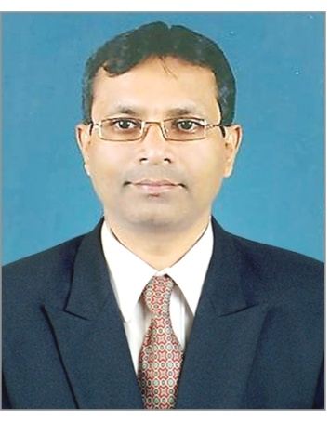

1.Name –Dr. Bhupal Ramchandra Divekar

2.Department- English

3. Educational Qualification- M.A., M.Phil., Ph.D

4. Teaching Experience-29 Years.

5. Papers Published-10

6. Paper Presentation- 21

7.. Participation In:
A) Seminars: 13

B) Workshops: 19

C) Conferences -06

D) Training Prpogrammes- 06

8. . Orientation / Refresher/ Short Term Cources:10

