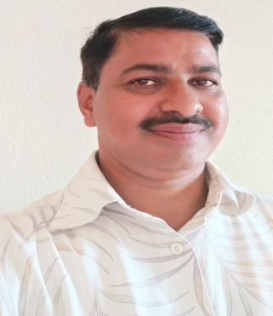
Name: Dr.S.E.Patil
Designation: Asst.Professor
- Qualification: M.Com, B.Ed, M.Phil, Ph.D
- Area of Expertise: Accounting and Finance
- Experience: 24 Years UG
- Email ID: saieepatil10@rediffmailmail.com
- Phone: 94213833677
Teaching Experience - 24 Years
Research Paper published- 15
Research papers presented are 10
Conference, Workshop, Seminar attended are More than 50

