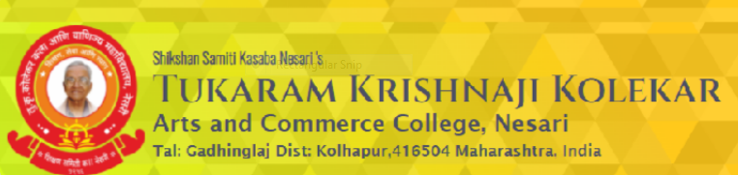
STUDENT STATISFACTION SURVEY QUESTIONNARIE DEVELOPED BY COLLEGE
1. How much of the syllabus was covered in the class?
A. 86 to 100% B. 70 to 84% C. 55 to 69% D. 30 to 54% E. Below 30%
2. How well did the teachers prepared for the class ?
A. Thoroughly B. Satisfactorily C. Poorly D. Indifferently E. At all won’t reach
3. How well the teachers able to communicate ?
A. Always effective B. Sometimes effective C. Just satisfactory D. Generally ineffective E. Very poor communication
4. Fairness of the internal evaluation process by the teachers.
A. Always fair B. Usually fair C. Sometimes unfair D. Usually unfair E. Unfair
5. The teachers approach to teaching can be best described as
A. Excellent B. Very good C. Good D. Fair E. Poor
6. Was your performance in assignments discussed with you ?
A. Every time B. Usually C. Sometimes D. Rarely E. Never
7. Teaching and mentoring process in your institute facilitates you in cognitive, social and emotional growth.
A. Significantly B. Very well C. Moderately D. Marginally E. Not at all
8. The institute takes active interest in promoting internship, student exchange, field visit opportunities for students.
A. Regularly B. Often C. Sometimes D. Rarely E. Never
9. The institution provides multiple opportunities to learn and grow.
A. Strongly agree B. Agree C. Neutral D. Disagree E. Strongly disagree
10. The Teachers inform you about your expected competencies, course outcomes and programme outcomes.
A. Every time B. Usually C. Sometimes D. Rarely E. Never

11. Your Mentor does a necessary follow-up with an assigned task to you.
A. Every time B. Usually C. Sometimes D. Rarely E. Never
12. The teachers illustrate the concepts through examples and other sources.
A. Every time B. Usually C. Sometimes D. Rarely E. Never
13. The teachers identify your strength and encourage you with providing right level of challenge.
A. Fully B. Reasonably C. Partially D. Slightly E. Unable to
14. The Teachers are able to find your weaknesses and help you to overcome them.
A. Every time B. Usually C. Sometimes D. Rarely E. Never
15. The institute makes effort to engage students in the mentoring, review and continuous quality improvement of the teaching- learning process.
A. A. Strongly agree B. Agree C. Neutral D. Disagree E. Strongly disagree
16. The Institute/ teachers use student centric methods, such as experiental, participative learning, review and continuous quality improvement of the teaching learning process.
A. To a great excellent B. Moderate C. Somewhat D. Very little E. Not at all
17. The Teachers encourage you to participate in extra-curricular activities.
A. A. Strongly agree B. Agree C. Neutral D. Disagree E. Strongly disagree
18. Efforts are made by the institute/teachers to inculcate soft skills, life skills and employability skills to make you ready for the world of work.
A. To a great excellent B. Moderate C. Somewhat D. Very little E. Not at all
19. What percentage of teachers use ICT tools such as OHP, Multimedia etc. while teaching.
A. Above 90% B. 70-89% C. 50-69% D. 30-49% E. Below 29%
20 The overall quality of teaching learning process in your institute is very good.
A. A. Strongly agree B. Agree C. Neutral D. Disagree E. Strongly disagree

